Top of the Morning, June 8, 2019

Sat, 06/08/2019 - 6:00am | Jim Rossow
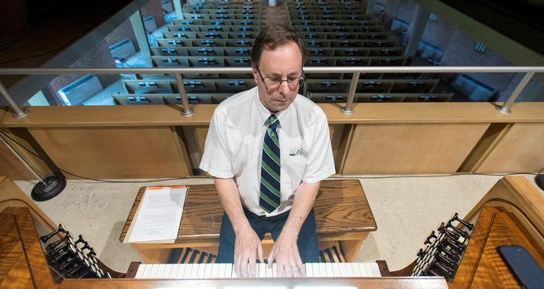KEITH WILLIAMS (above) as spent countless hours both renovating and playing the sprawling pipe organ at St. John Lutheran Church in Champaign.
See — and hear — for yourself at 4 p.m. Sunday when the church celebrates the completion of a seven-year, 450-pipe project with a concert led by Williams playing classics from the likes of Bach, Buxtehude, Durufle and Praetorius.
"It's a dream come true," said Williams, whose roles at Buzard Pipe Organ Builders (service director) and St. John (organist) were both critical to the process.
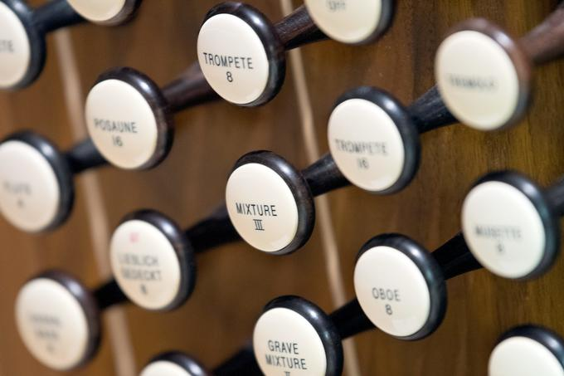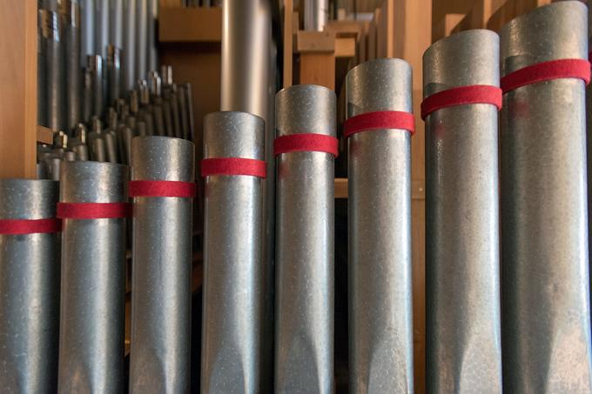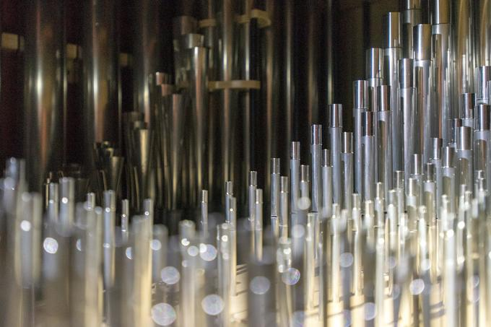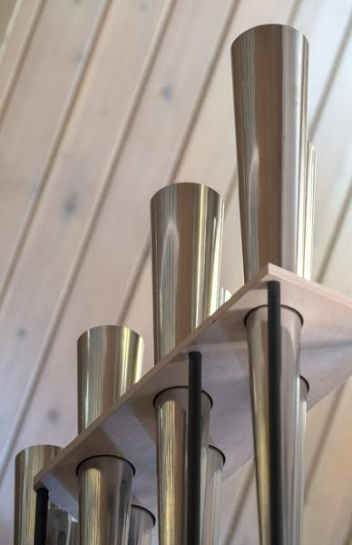The organ, now considered the second-largest in C-U behind the one at University Place Christian Church, is up to 2,050 pipes, 37 ranks and 30 stops. A new one its size, Williams said, would run about $1.3 million.
"It's not something you pay out of pocket change," he said.
St. John's upgrade of an organ installed in 1976 started in 2012 with a rebuilt console, new control system and tonal re-engineering. At a pastor's conference soon thereafter, "they were completely blown away," Williams said. "That led to interest in finishing the job. You could hear the difference."
In his 49th year as a church organist — 19th at St. John — Williams tried out the finished product on Easter Sunday.
"This is more fun to play than the organ in 2000," he said. "More variety, more color, more depth of sound."
Sunday's concert and choir reception are open to the public. Williams, 64, will be in his element.
"No one has said, 'Gee, why'd you do that?'" he said. "The feedback has been all positive. It's still the best instrument to lead a congregation in song."

