Available pipe organ, built by Trent Buhr
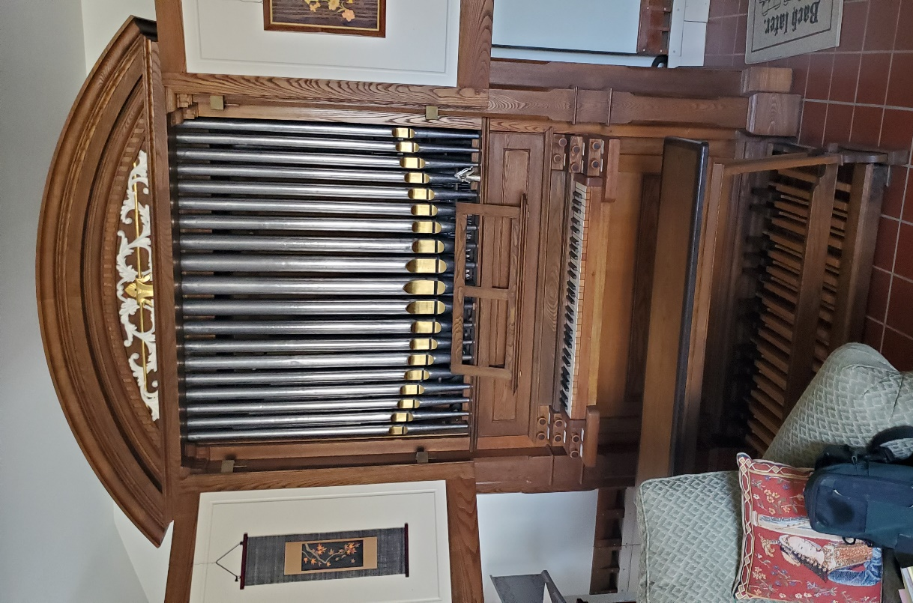

Left hand side of keyboard – Manual stops Right hand side of keyboard - Pedal stops:
All divided bass & treble except (Dulciana) Subbass 16'
Gedeckt 8’ Bourdon 8' (ext)
Dulciana 8’ Flute 4' (ext)
Prestant 4’
Principal 2’ Tremolo
Traverse Flute 4’
Quint/Tierce

Main casework is 64-1/2” wide by 32” deep plus 23” for pedalboard
Case is 85-1/2” tall plus 13” for molding at top (which is removable)
The bass windchests for the Pedal Subbass are each 6” x 24-1/2”.
Mechanical action for Manual, electromechanical action for Pedal stop

